CARIAD SE CPM Project

Functional Specification

Skip Error Message on Assigning Items

|  |  |
| --- | --- |
| Person Responsible: | Jimmy Xu |
| Status: | in review |
| Version: | V1.0 |
| Date: | 05/02/2025 |
|  |  |
|  |  |
|  |  |

Version History:

| Version | Date | Author | Comments |
| --- | --- | --- | --- |
| V1.0 | 05/02/2025 | Jimmy Xu |  |
|  |  |  |  |
|  |  |  |  |

# Business Purpose

With standard PFM, one item could only be assigned to one Initiative.

However, in CARIAD, Initiatives are created as yearly OP and SP. Same portfolio items could be assigned to OPs or SPs for every year’s planning round process. An enhancement will be implemented for this purpose.

# Functional Specification

## Overview

In standard PFM, one item can be assigned to only one initiative.

An error message occurs when assign an item to initiative if the item is already assigned to some other initiative.

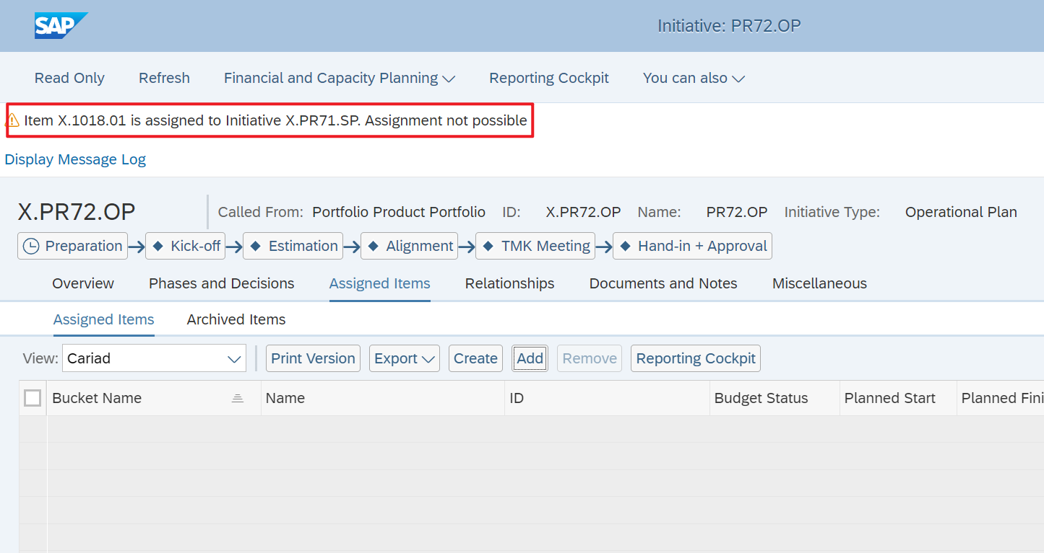

## Enhancement

Enhance on saving initiative. Class: /RPM/CL_WD_ALV_REL_ITEM_REUSE

Skip the error message.

# Authorization

NA

# Others